GYM ME WEBSITE

Software Requirements Specification

09 April 2024

ABHISHEK - 12105646

Prepared for
Continuous Assessment 3
Spring 2024

Table of Contents

Revision History ii
CLIENT Approval ii
1. Introduction 1
1.1 Purpose 1
1.2 Scope 1
1.3 Definitions, Acronyms, and Abbreviations 1
1.4 References 1
1.5 Overview 1
2. General Description 2
2.1 Product Perspective 2
2.2 Product Functions 2
2.3 User Characteristics 2
2.4 General Constraints 2
2.5 Assumptions and Dependencies 2
3. Specific Requirements 2
3.1 External Interface Requirements 3
3.1.1 User Interfaces 3
3.1.2 Hardware Interfaces 3
3.1.3 Software Interfaces 3
3.1.4 Communications Interfaces 3
3.2 Functional Requirements 3
3.2.1 <Functional Requirement or Feature #1> 3
3.2.2 <Functional Requirement or Feature #2> 3
3.5 Non-Functional Requirements 4
3.5.1 Performance 4
3.5.2 Reliability 4
3.5.3 Availability 4
3.5.4 Security 4
3.5.5 Maintainability 4
3.5.6 Portability 4
3.7 Design Constraints 4
3.9 Other Requirements 4
4. Analysis Models 4
4.1 Data Flow Diagrams (DFD) 5
5. Github link…………………………………………………………………………………………………….5

1. Introduction

The Software Requirements Specification (SRS) document serves as a comprehensive guide outlining the requirements for the development of the Gym Me Gym website. It is intended to provide software engineers with all the necessary information to effectively design and implement the software product according to the specified requirements. The following subsections, largely derived from the IEEE Guide to SRS, will provide a structured overview of the complete SRS document.

1.1 Purpose

The purpose of this SRS is to clearly define the functional and non-functional requirements of the Gym Me Gym website. It serves as a foundational document that guides the development process, ensuring alignment with stakeholder expectations and project objectives. By detailing the specific features and characteristics of the software product, this document facilitates communication between stakeholders and development teams, ultimately leading to the successful delivery of a high-quality website.

1.2 Scope

This subsection identifies the scope of the Gym Me Gym website project, outlining the software product to be produced and its intended functionalities. The website will encompass various sections, including a homepage, pricing section, login/sign up section, training list section, and about section. Additionally, it will be designed to be compatible and responsive to devices with different screen sizes and resolutions, ensuring accessibility across a wide range of platforms.

1.3 Definitions, Acronyms, and Abbreviations

- UI: User Interface - The means by which a user interacts with a software application, including graphical elements such as buttons, menus, and forms.

- UX: User Experience - The overall experience of a user when interacting with a software application, encompassing aspects such as usability, accessibility, and satisfaction.

- API: Application Programming Interface - A set of rules and protocols that allows different software applications to communicate with each other, enabling the exchange of data and functionality.

- HTTP: Hypertext Transfer Protocol - The protocol used for transmitting data over the internet, commonly used for fetching resources such as HTML documents, images, and scripts.

- CSS: Cascading Style Sheets - A style sheet language used for describing the presentation of a document written in HTML, defining aspects such as layout, colors, and fonts.

- HTML: Hypertext Markup Language - The standard markup language used for creating web pages and web applications, defining the structure and content of a document.

- DBMS: Database Management System - Software that allows users to create, retrieve, update, and manage databases, providing mechanisms for storing, organizing, and querying data.

- UI/UX Design: User Interface/User Experience Design - The process of designing and optimizing the user interface and experience of a software application, focusing on usability, accessibility, and visual appeal.

- QA: Quality Assurance - The process of ensuring that a software product meets specified requirements and standards, typically involving testing, debugging, and validation activities.

- CMS: Content Management System - A software application or set of tools that allows users to create, manage, and publish digital content on the web, often used for websites and blogs.

- URL: Uniform Resource Locator - A reference to a web resource that specifies its location and how to retrieve it, typically consisting of a protocol, domain name, and path.

- SSL: Secure Sockets Layer - A protocol for securing data transmission over the internet by encrypting the communication between a client and server, commonly used for securing online transactions and sensitive information.

- SEO: Search Engine Optimization - The process of improving the visibility and ranking of a website in search engine results, typically involving optimizing content, metadata, and website structure.

1.4 References

- React Documentation:

- Title: React Documentation
- Author: Facebook
- Date: Accessed April 2024
- URL: https://reactjs.org/docs/getting-started.html

- Tailwind CSS Documentation:

- Title: Tailwind CSS Documentation
- Author: Tailwind Labs
- Date: Accessed April 2024
- URL: https://tailwindcss.com/docs

1.5 Overview

This subsection provides a brief overview of the content and organization of the SRS document. It outlines the main sections and their respective purposes, guiding the reader through the document structure. By clearly delineating the sections and their objectives, the overview sets expectations for what information will be covered and how it will be presented in the subsequent sections of the SRS.

2. General Description

The General Description section provides an overarching view of the Gym Me Gym website, highlighting its positioning, functionalities, target users, constraints, assumptions, and dependencies.

2.1 Product Perspective
The Gym Me Gym website is a standalone product that serves as the primary online platform for the gym. It is not directly integrated with other related products or projects. However, it may interact with external systems such as payment gateways, user authentication services, and content management systems for data exchange and integration.

2.2 Product Functions
The Gym Me Gym website performs a variety of functions to meet the needs of its users, including:

- Providing information about the gym's services, facilities, and training programs.
- Facilitating membership registration, renewal, and account management.
- Enabling users to browse and book training sessions, classes, and events.
- Offering personalized recommendations and notifications based on user preferences and activity history.
- Integrating social media platforms for community engagement and sharing.

2.3 User Characteristics
The eventual users of the Gym Me Gym website include:

- Gym members: Individuals who have registered for memberships and utilize the gym's facilities and services.
- Prospective customers: Individuals who are interested in joining the gym and exploring its offerings.
- Gym staff/administrators: Personnel responsible for managing memberships, scheduling training sessions, and updating website content.
- Users are expected to have basic internet browsing skills and access to compatible web browsers across various devices.

2.4 General Constraints
General constraints that may impact the development of the Gym Me Gym website include:

- Compatibility and responsiveness requirements across different devices and screen sizes.
- Compliance with data protection regulations (e.g., GDPR) to ensure user privacy and security.
- Integration with third-party services and APIs for payment processing, user authentication, and content management.
- Adherence to web development best practices and standards for accessibility, performance, and usability.

2.5 Assumptions and Dependencies
Factors that may affect the requirements stated in the SRS include:

- Assumption that users have access to stable internet connectivity to access the website.
- Dependency on third-party services and APIs for features such as payment processing and social media integration.
- Assumption that the website will be hosted on a reliable web hosting platform capable of handling expected traffic volumes.
- Dependency on the availability of resources such as hardware, software libraries, and development tools to implement the required features and functionalities.

3. Specific Requirements

This section outlines the specific requirements of the Gym Me Gym website, guiding the project's software design, implementation, and testing. Each requirement is meticulously defined to ensure correctness, traceability, unambiguity, verifiability, prioritization, completeness, consistency, and uniqueness.

3.1 External Interface Requirements

3.1.1 User Interfaces

- The user interface (UI) of the Gym Me Gym website shall be intuitive, visually appealing, and easy to navigate.
- All UI elements, including buttons, menus, forms, and content blocks, shall adhere to responsive design principles to ensure compatibility across various devices.
- UI components shall be designed with accessibility in mind, following WCAG (Web Content Accessibility Guidelines) standards to accommodate users with disabilities.

3.1.2 Hardware Interfaces
The Gym Me Gym website does not have direct hardware dependencies and interfaces.

3.1.3 Software Interfaces
- The website shall integrate with third-party software services and APIs for functionalities such as payment processing, user authentication, and content management.
- APIs used for integration shall be well-documented, stable, and supported to ensure reliable communication between the website and external systems.

3.1.4 Communications Interfaces
- The website shall utilize secure communication protocols (e.g., HTTPS) to encrypt data transmission between the client and server, ensuring confidentiality and integrity of user information.
- Communication interfaces shall support asynchronous communication for real-time updates and notifications, enhancing user engagement and experience.

3.2 Functional Requirements

3.2.1 Membership Registration
- Introduction: Allow users to create new accounts by providing necessary personal information, including name, email address, and password.
- Inputs: User-provided information, including name, email, password, and any additional required fields.
- Processing: Validate user input, check for duplicate accounts, and securely store user information in the database.
- Outputs: Confirmation message upon successful registration, including instructions for account activation if required.
- Error Handling: Display error messages for invalid input, duplicate accounts, or server errors during registration process.

3.2.2 Training Session Booking
- Introduction: Enable registered users to browse available training sessions, select desired sessions, and book slots.
- Inputs: User-selected training session, preferred date and time, and any additional preferences or requirements.
- Processing: Check session availability, reserve slot for the user, and update session booking status in the database.
- Outputs: Confirmation message with booked session details, including date, time, and location.
- Error Handling: Notify user of session unavailability or conflicts, and provide options for alternative sessions.

3.2.3 Membership Renewal
- Introduction: Provide registered users with the ability to renew their memberships online.
- Inputs: User authentication credentials, membership renewal options (e.g., duration, payment method).
- Processing: Verify user credentials, calculate renewal fees based on selected options, and update membership status upon successful renewal.
- Outputs: Confirmation message with renewed membership details, including new expiration date.
- Error Handling: Notify user of any payment processing errors, invalid credentials, or other issues preventing membership renewal.

3.5 Non-Functional Requirements

3.5.1 Performance
- The website shall load within 3 seconds on average, ensuring a seamless user experience and minimizing bounce rates.
- Concurrent user sessions shall be supported without significant degradation in performance, with a minimum capacity of 100 simultaneous users.

3.5.2 Reliability
- The website shall have a minimum uptime of 99.9% per month, ensuring continuous availability to users.
- Backup and recovery mechanisms shall be implemented to mitigate data loss in the event of system failures or disasters.

3.5.3 Availability
- The website shall be accessible 24/7, allowing users to access services and information at any time.
- Scheduled maintenance activities shall be communicated to users in advance, minimizing disruption to service availability.

3.5.4 Security
- User authentication and session management mechanisms shall be implemented to protect user accounts from unauthorized access.
- Data transmission between the client and server shall be encrypted using HTTPS to prevent eavesdropping and tampering.
- Regular security audits and vulnerability assessments shall be conducted to identify and address potential security threats.

3.5.5 Maintainability
- The website shall be built using modular and well-documented code to facilitate ease of maintenance and future updates.
- Version control systems such as Git shall be utilized to track changes and collaborate on codebase management.

3.5.6 Portability
- The website shall be compatible with major web browsers, including Google Chrome, Mozilla Firefox, and Safari, ensuring consistent performance and appearance across platforms.
- Responsive design techniques shall be employed to optimize the website for viewing on various devices, including desktops, laptops, tablets, and smartphones.

3.7 Design Constraint
- The website design shall comply with brand guidelines and visual identity standards established by Gym Me Gym.
- Development shall adhere to industry best practices and coding standards, ensuring maintainability and scalability of the codebase.

3.9 Other Requirements
- The website shall comply with relevant legal and regulatory requirements, including GDPR (General Data Protection Regulation) for data privacy and protection.
- User feedback mechanisms shall be implemented to gather insights and suggestions for continuous improvement of the website.

4. Analysis Models

4.1 Data Flow Diagrams (DFD)

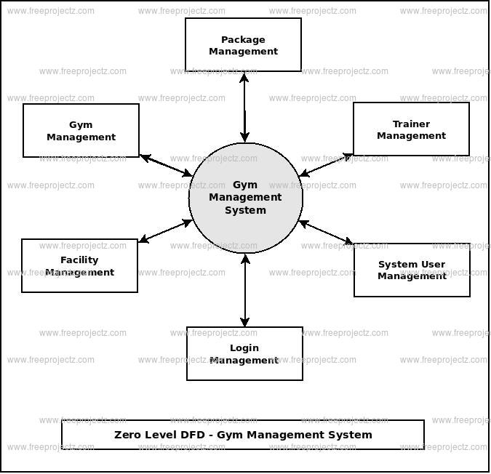

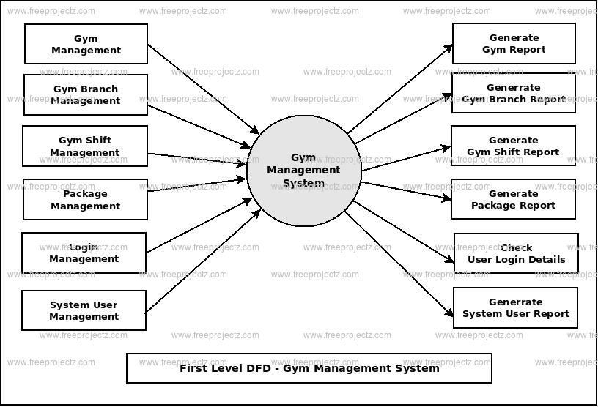

5. GitHub link

- GitHub repository - https://github.com/Bazuga02/gymx-react

- GitHub Pages Deployed - https://bazuga02.github.io/gymx-react/

